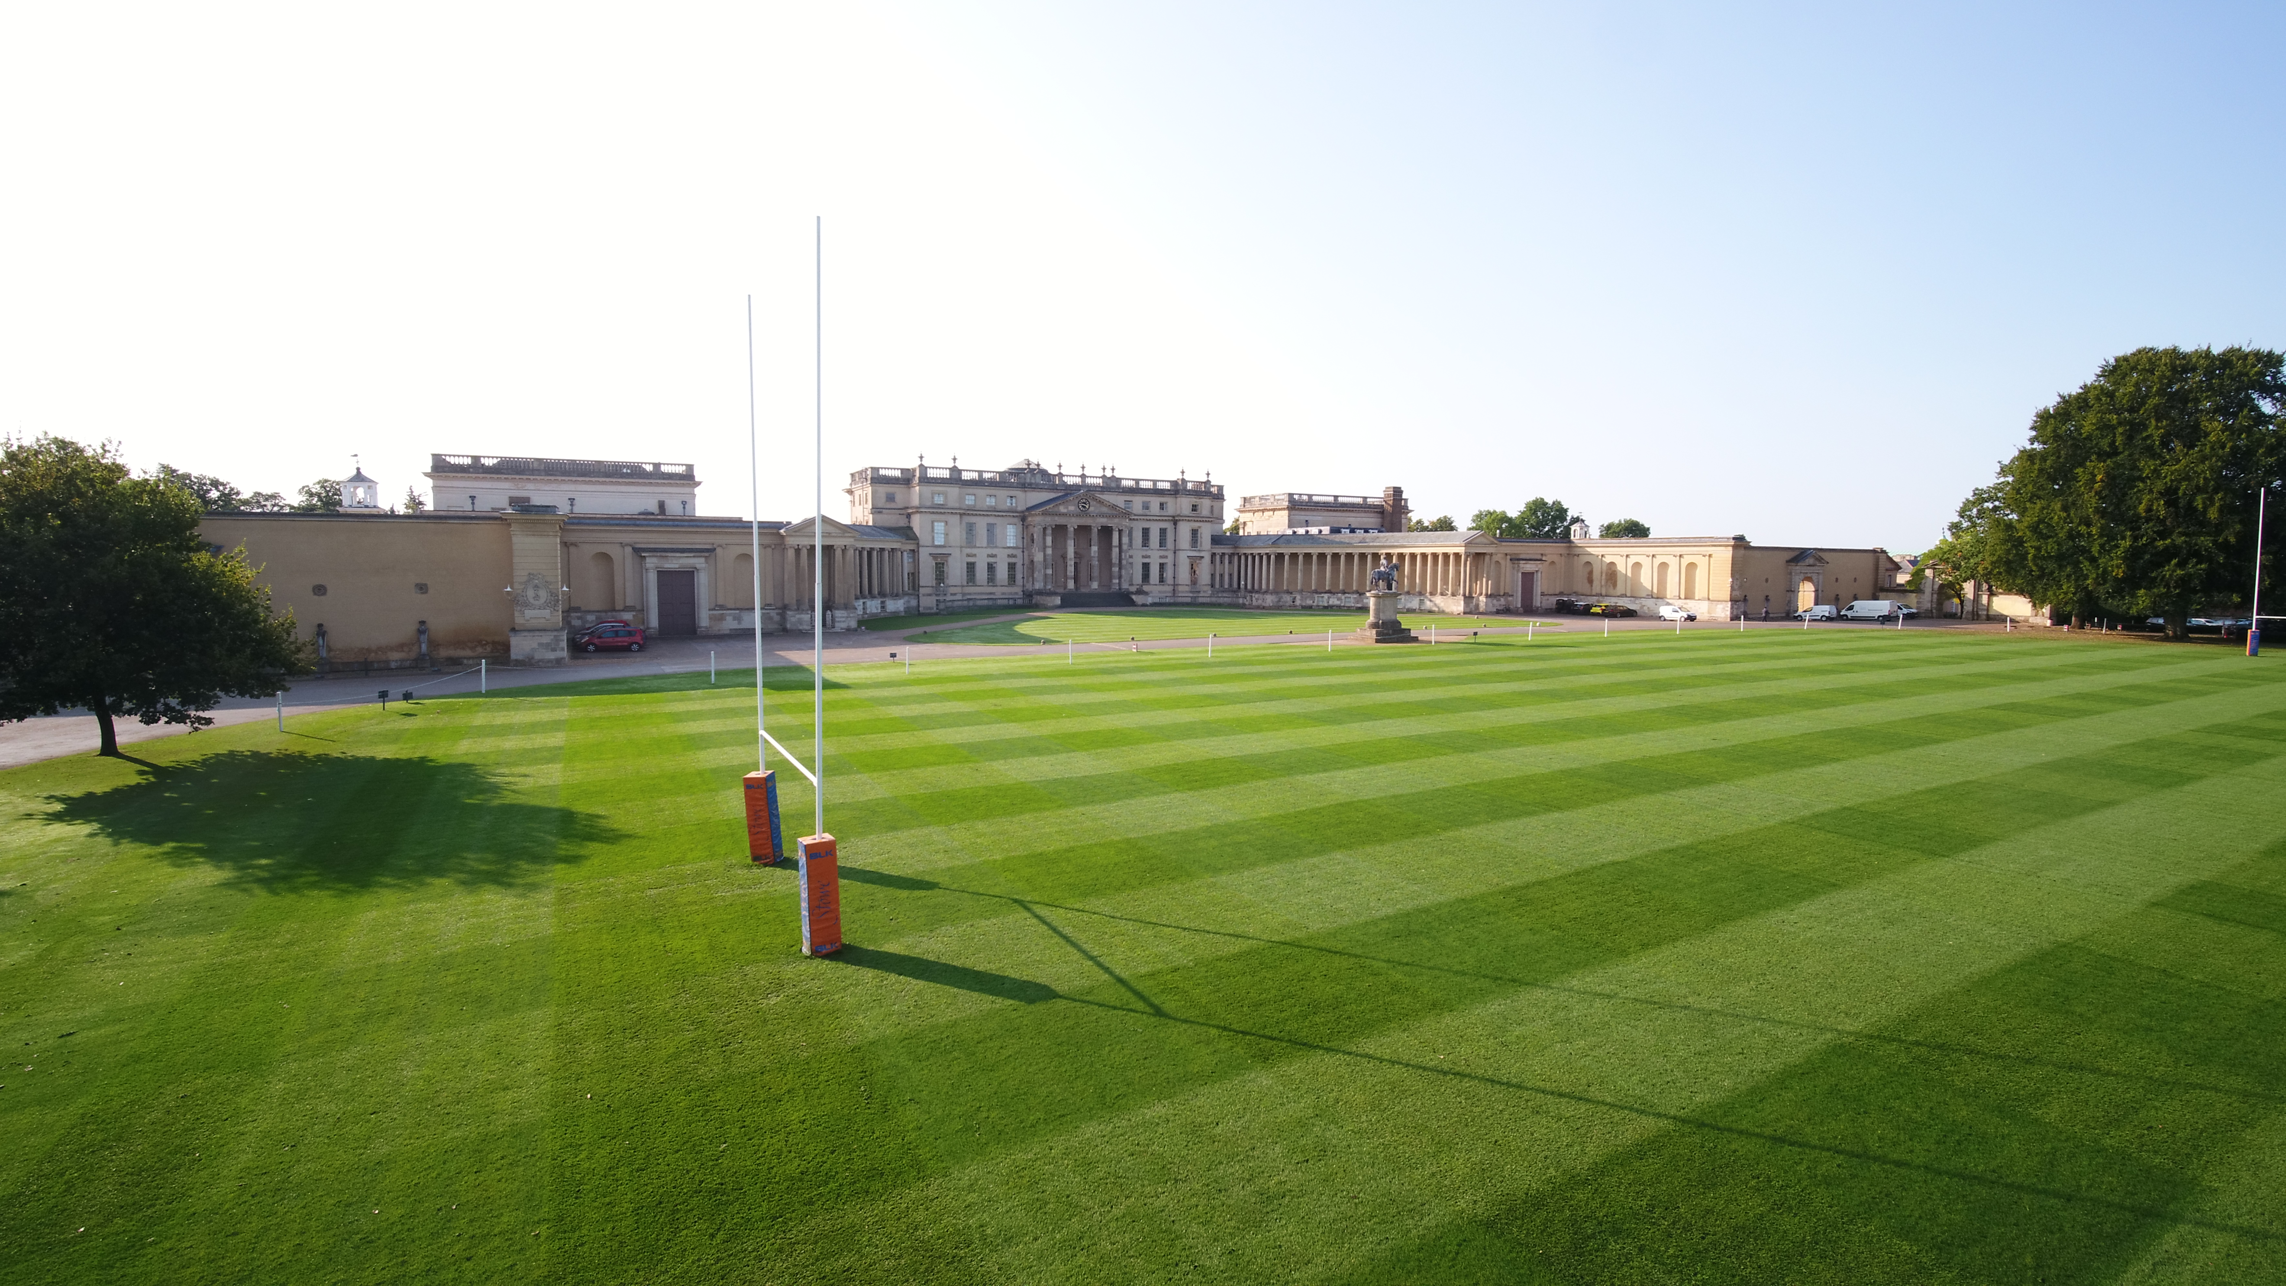
STOWE SCHOOL
PLACEMENT SPORTS COACH
SEPTEMBER 2024
For September 2024 Stowe School is looking to appoint Placement Sports Coaches with experience in any of the following sports – Rugby, Hocky (girls & boys), Cricket, Netball, Tennis, Lacrosse, Football, Swimming, Golf or S&C. We are looking for enthusiastic team players with a love of sport who are equally committed to participation as well as performance and have the ability to engage and motivate students. We welcome those with a specialism in one sport or all-rounders who are confident covering a variety of sports.
The successful candidate would be expected to teach practical PE and coach across a wide range of ages and abilities in the Senior School, including an opportunity to help sports award holders who are part of the High Performance Programme.

There will also be an opportunity to coach at Swanbourne House and Winchester House Prep School’s (both Co-Ed ages 3-13).

The role requires the candidates to be integral members of 7-day-a-week boarding schools and as such includes pastoral responsibilities in the boarding houses.

The department is committed to career progression and training. We can assist with getting additional coaching qualifications and attending specialist courses to enhance your coaching CV.

The position comes with a salary, accommodation and full board and is fixed term until July 2025.

If you wish to apply, please fill in an application form that is available on our website: Stowe - Current Vacancies

Closing date: 25 February 2024
Assessment Centre: TBC which will be held at Stowe School

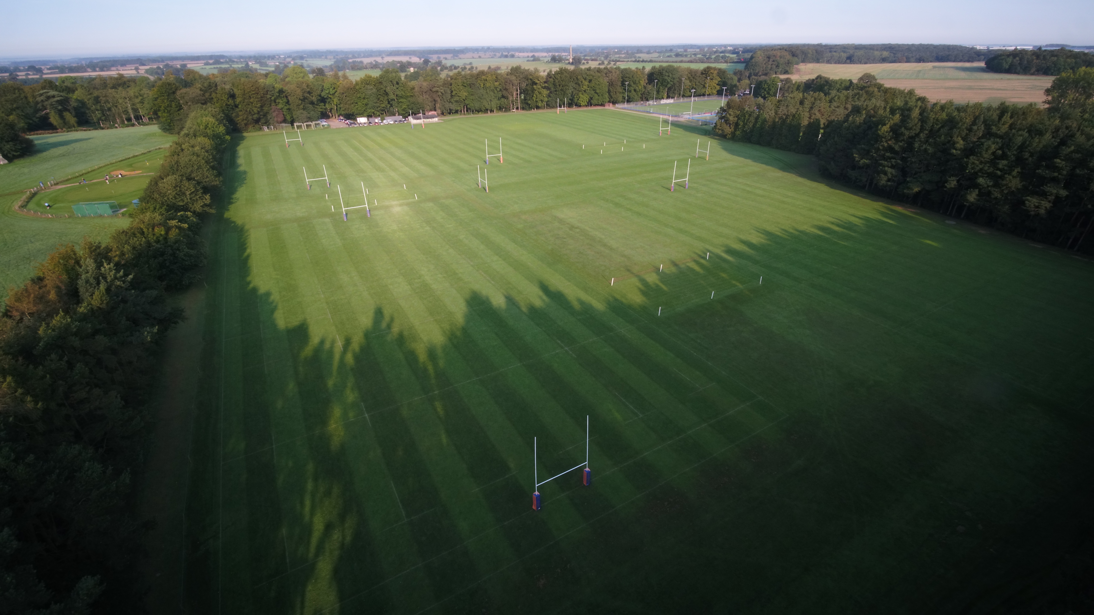
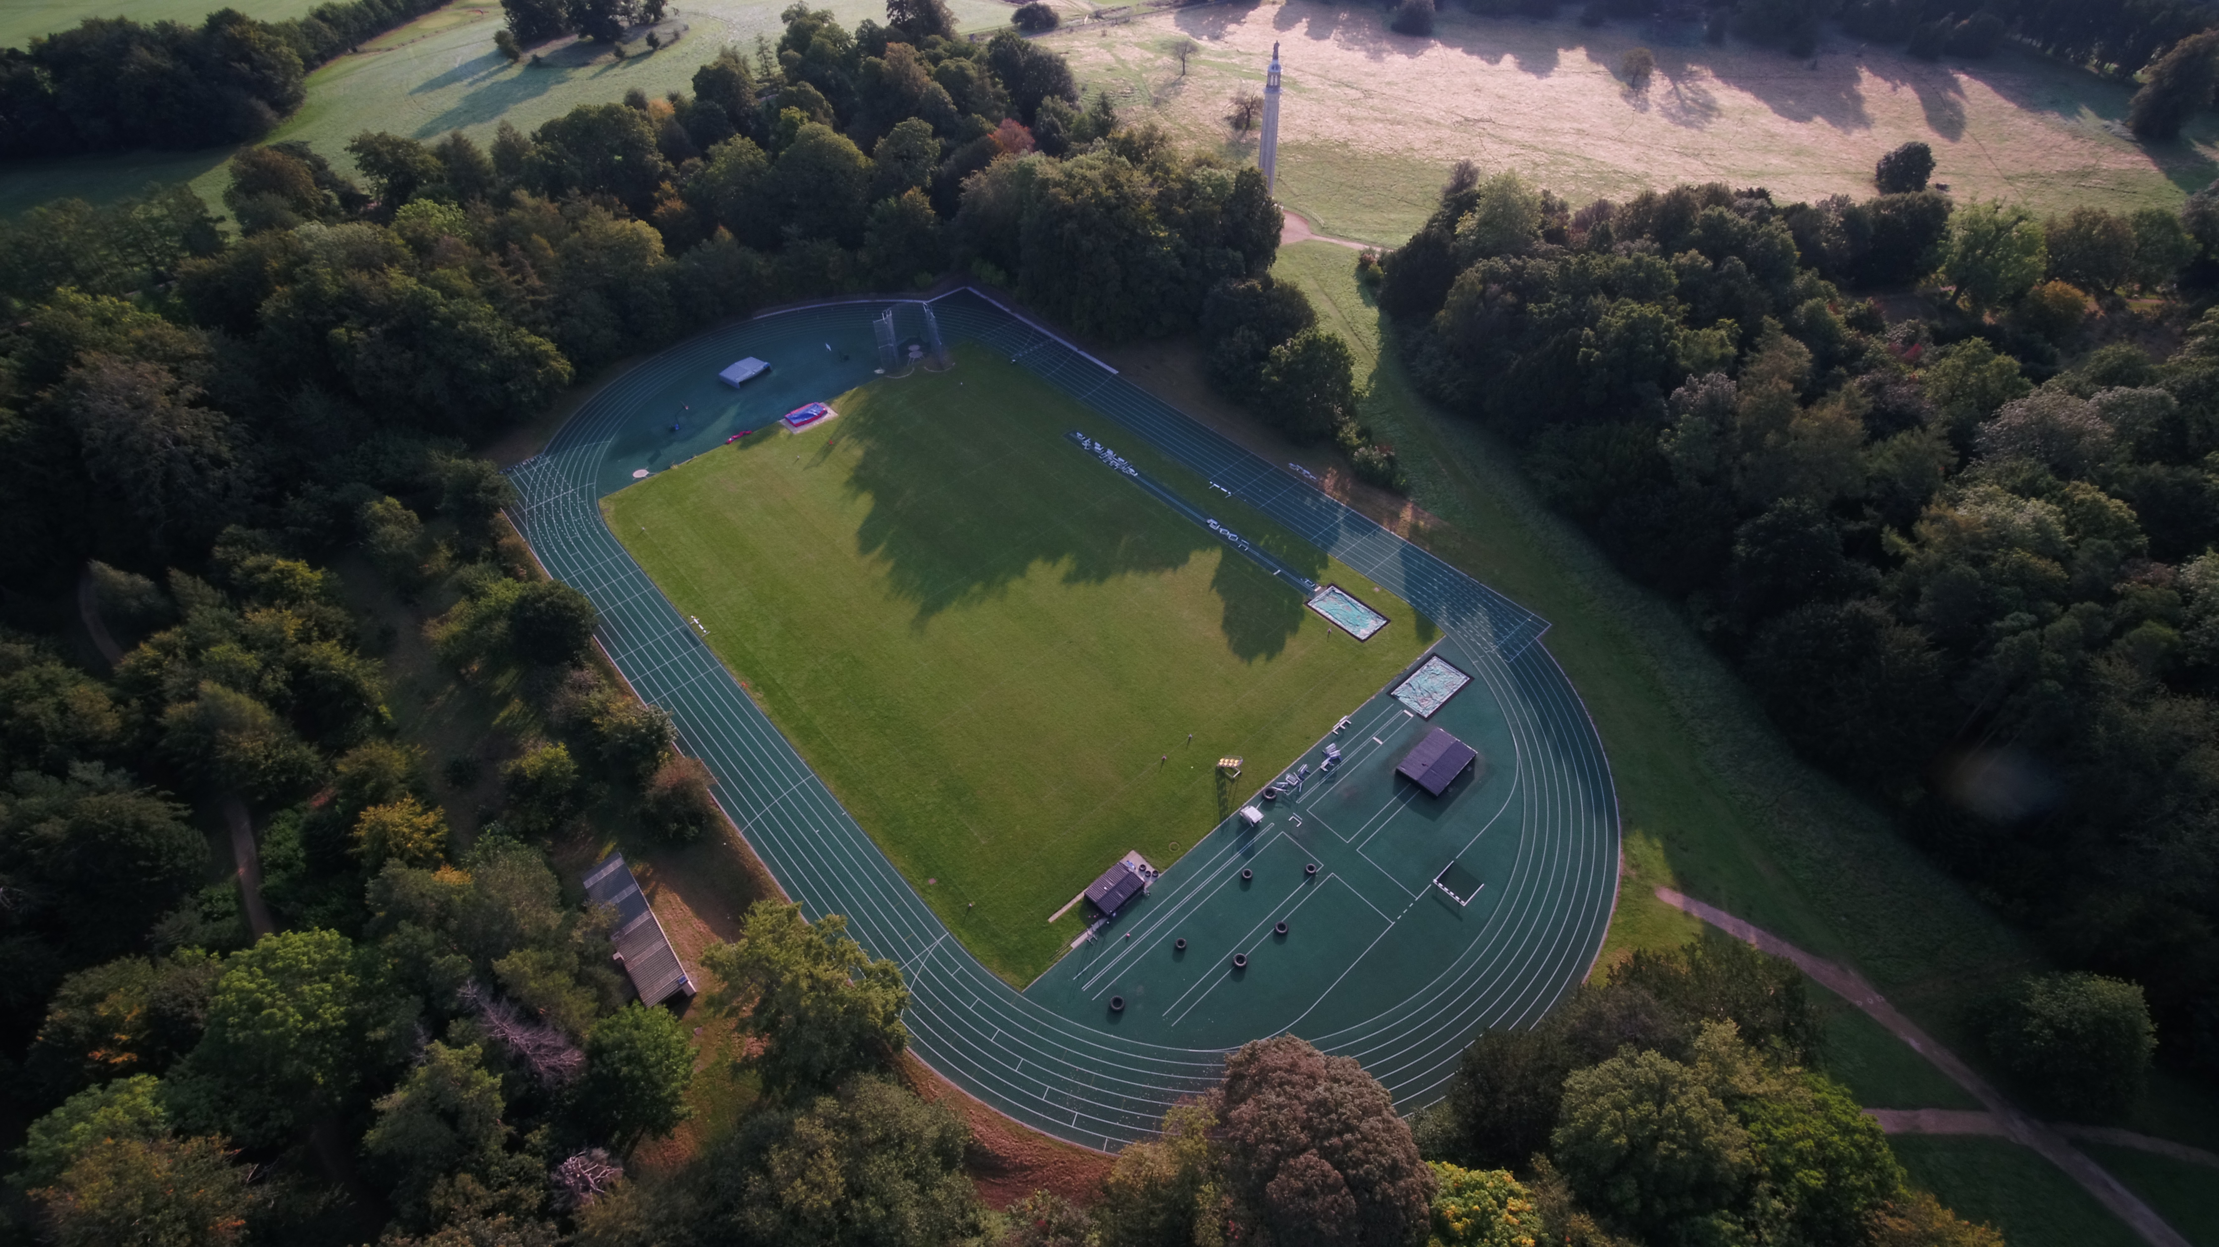
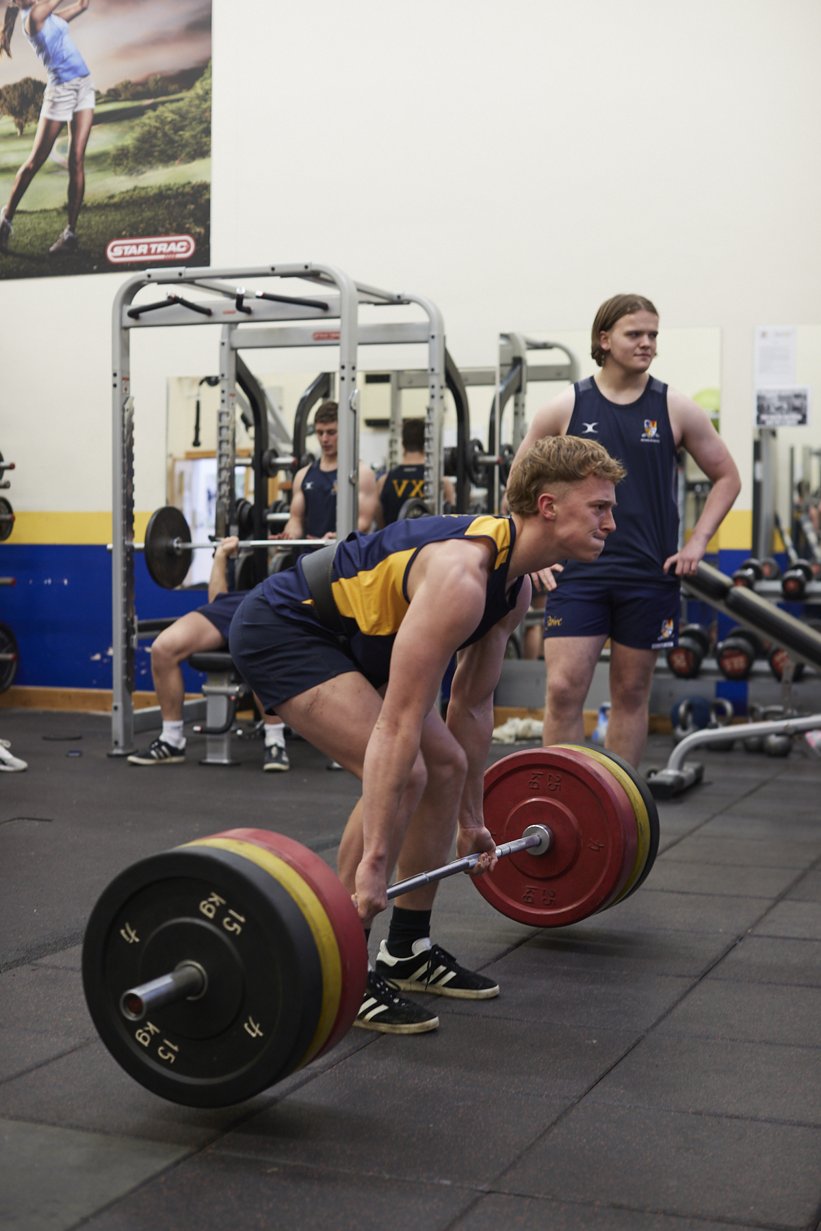
‘I was really interested in joining Stowe School so I could apply the knowledge I learnt at university into a practical role. Stowe is a very rewarding, friendly and dynamic place to work.’

Jess, Graduate Sports Coach 2023/24 (from University of Birmingham)

Harriett Moore (previous Loughborough Student) says ‘I have thoroughly enjoyed my time working at Stowe School and Winchester House Prep School. Being able to contribute and learn across both schools has meant I have had many opportunities within a range of different sports. The staff at Stowe are welcoming, meaning I have been able to gain and develop both my personal and professional skills within a fun team environment. I have gained a huge amount of practical coaching experience and sporting knowledge both out on the field and in the gym. Outside of sport, I have worked in the girls boarding house at Winchester House School playing a role in the students evening activities and their everyday boarding life. The amazing facilities and grounds, along with the friendly culture makes Stowe the ideal environment for a placement.’


‘What really caught my attention about working for Stowe was the opportunity to work in multiple aspects of sport. Stowe offers me the chance to broaden my horizons, try sports and aspects of life I haven’t done before.’

Jack, Placement Sports Coach 2022/23 (from Anglia Ruskin University)

Job Title: Placement Sports Coach
Accountable to: Directors of Sport and Pastoral Heads
Responsible for: N/A

Purpose of the job:

To be integral parts of the academic and pastoral communities within the Stowe Group schools. Primary roles are to be part of the schools’ Sports Departments and the pastoral teams supporting the boarding houses. This appointment encompasses roles across the schools within the Stowe Group.

The Stowe Group

The Stowe Group comprises Stowe, Swanbourne House and Winchester House Independent Schools, situated on sites in Buckinghamshire and Northamptonshire. Between the three schools, The Stowe Group can offer education for boys and girls from 3-18 years. Within The Group there are more than 1,400 pupils and 600 members of staff. The Schools occupy sites of historical significance in Swanbourne, in the market town of Brackley and in the beautiful landscape gardens at Stowe, where we work with The National Trust to manage the landscape gardens and open the grounds to over 200,000 visitors a year. Stowe House is open to the public during the School holidays and for guided tours during term time. The Stowe Group is committed to safeguarding and promoting the welfare of children and expects all staff to share this commitment. In 2021, The Stowe Group launched its transformational and substantive Change Makers vision.

Vision & Ethos

We are Change Makers

Our goal is to inspire pupils and staff to be Change Makers who will shape positive futures for themselves, their families and the global community. Our World-class facilities support our educational aims and are shared with the wider community. We strive for excellence and celebrate achievement, valuing education as a journey and not a destination in the belief that all pupils can exceed their potential. Learning is learnable and everyone can improve. Our aim is to encourage personal development by creating a flourishing, vibrant, cohesive, caring and socially inclusive community which embraces pluralism, diversity and intercultural understanding. We celebrate differences by giving everyone a voice and then listening to multiple viewpoints. It is our collective responsibility to develop the cognitive, physical, emotional and spiritual well-being of everyone in our community. We are committed to the development of character with particular emphasis on tolerance, resilience, honesty, humility, courage, compassion, gratitude and service. We strive to attract and retain employees of the highest calibre. The Group’s talented and committed workforce is one of our greatest strengths. We are committed to fostering team engagement, attracting, mentoring, developing and retaining our best teachers and support staff. We focus on employee well-being, provide opportunities for professional growth and create a culture of community and partnership. Environmental stewardship and sustainability are cornerstones of The Stowe Group. Pupils and staff have a heightened awareness of their social and environmental responsibility in preserving our unique eco-system. We have developed and implemented a comprehensive Environmental Stewardship Programme which confronts a variety of challenges, including climate change and environmental sustainability

Key Responsibilities and Accountabilities:

- To promote the aims of the Group at all times with colleagues, parents, pupils and the public
- To play a full part in seven day a week boarding Schools with commitment to teaching, pastoral care, extra-curricular activities and School duties.
- To assist in the recruitment of pupils and to promote the Schools and Departments.
- To provide professional high quality teaching/coaching, with the effective use of appropriate resources and the highest standards of learning and achievement of all pupils.
- To attend all appropriate Health & Safety (COSHH) and Child Protection training issues related to the pupils, Schools and Departments.

Key Tasks:

1. Coaching/Management/Administration

- To coach sports as required in the games and activities programme as directed by the Directors of Sport.

- To attend matches and tournaments as required

- To supervise and run activities.

- To attend INSET for continued professional development

- To give feedback to players to develop their performance and understanding

- To organise the filming of matches.

- To assist with video analysis, including organising and clipping footage so that it is ready for review

- Ensuring all coaches are able to access the match footage and use it for team analysis and feedback sessions

- To develop links with other Prep and local schools.

- To assist the Directors of Sport in the delivery of the Sports Scholarship programmes.

- To undertake any additional duties within reason as defined by the Directors of Sport and Pastoral Heads.

- To ensure adherence to statutory Health and Safety and Data Protection Legislation at all times.

- To ensure compliance with the current teaching staff handbooks.

2. Social and moral welfare of pupils

- To take responsibility for the educational, social and moral welfare of pupils in the context of Stowe Group's boarding communities.

- Contribute to the pastoral well being of the pupils by being a member of staff on duty in the boarding houses during the evening and overnight.

3. Assessments and reports

- To provide or contribute to oral and written assessments, reports and references relating to individual pupils and groups of pupils.

4. Review and Professional Development

- To keep abreast of developments in his/her sport(s) and its coaching methods in order to maintain a high level of professional competence Staff should also participate in arrangements within the agreed framework for review and professional development, including INSET.

5. Discipline, Health and Safety

- To maintain good order and discipline among pupils and safeguarding their health and safety both on the School premises and when they are engaged in School and other activities elsewhere, within the framework of the Health and Safety Policy documents.

- To adhere to and manage all appropriate Health & Safety legislation, risk assessments and Child Protection training issues.

6. Meetings

- To participate in all meetings which relate to the school curriculum, school organisation and school administration and to attend Chapel, assemblies and other school events as required by the Heads of schools.

7. School Duties

- To undertake the supervision of pupils during breaks, at meal times, in detention, on school journeys and on school premises as required by the duty rota.

- To be accommodated on site as required for the execution of your duties.

8. Salary/package: Competitive salary and accommodation available (where appropriate)

This job description reflects the present requirements of the post and as duties and responsibilities change/develop, the job description will be reviewed and be subject to amendment in consultation with the post holder.

Date agreed: January 2024

Stowe School is committed to safeguarding and promoting the welfare of children. Applicants must be willing to undergo child protection screening appropriate to the post, including checks with past employers, the Disclosure and Barring Service and an online background check with our third party provider SP-Index.

Person Specification

The selection of candidates for short-listing will be based on this specification and candidates should bear this in mind when preparing their application and completing the application form:

Attributes | Essential | Desirable
Qualifications |  | - A good degree or currently working towards a degree
Specialist Skills & Experience | - Personally committed to continued professional development  - The ability to transfer your enthusiasm and knowledge of sport to the pupils | - The ability to play and coach at least 2 sports to a high level  - Ability to referee in at least one sport  - Good ICT skills  - Driving licence
Personal Qualities | - Hard Working, Enthusiastic and energetic  - Good team player  - Patience and a sense of humour  - Good organisational skills  - Good professional manner and appearance  - Excellent practitioner able to inspire pupils in the love of (your) sport  - Ability to communicate effectively with pupils, staff and parents  - Willingness to contribute fully to the life of busy boarding schools

