Job Description

Job Title: | CBT Therapist (School-Based)
Hours of Work: | 10
Department: | Pastoral
Accountable to: | Deputy Head Pastoral & DSL
Number of direct reports: | None
Budgetary responsibility: | None
Location: | Stowe School
Purpose of the role: | We are seeking a qualified and compassionate Cognitive Behavioural Therapist (CBT) to join our school team to provide evidence-based therapeutic support to pupils. The successful candidate will focus on helping pupils manage emotional, behavioural, and mental health challenges to improve their well-being and academic performance. The role requires close collaboration with teachers, parents, school staff, and external professionals to create a nurturing and supportive environment for all pupils.
The Stowe Group
The Stowe Group of schools (Stowe, Ashfold School, Swanbourne House and Winchester House) was created in January 2021 and is situated on three separate sites in Buckinghamshire and Northamptonshire. Across the three schools, The Stowe Group offers education for boys and girls from 3-18 years. Within The Stowe Group there are more than 1,500 pupils and 850 colleagues. The Schools occupy sites of historical significance in Swanbourne, the market town of Brackley and the world-famous landscape gardens at Stowe, where we work with The National Trust to manage 880 acres and open the grounds to over 200,000 visitors a year. Stowe House is open to the public during the School holidays and for guided tours during term time. The Stowe Group is committed to safeguarding and promoting the welfare of children and expects all staff to share this commitment. In 2021, The Stowe Group launched its transformational and substantive Change Makers vision and Change 100 programme.
Vision & Ethos
We are Change Makers

Stowe stands in the most sublime setting of any school in the world. Historic buildings, landscaped gardens and the very spirit of the Enlightenment sit at the heart of its founding. But, as this remarkable landmark enters its second century as a leading public school, we believe that beauty and tradition are not enough: our future vision for the School embraces change, uncertainty and the challenges that will face our pupils not just during their academic careers, but throughout the rest of their lives in a world which is increasingly complex and ambiguous. Within that volatile environment we see our pupils and staff as Change Makers. They will make a lasting impact not only while they are here at Stowe, but, perhaps more importantly, in the wider world. The history of this place, both as a stately home and as a pioneering school remains important to our mission of education, and at the heart of a Stowe education remains intellectual enquiry, academic curiosity and a love of learning. We strive for a balance of rights and responsibilities, equality and inclusion and to treat each pupil and member of staff as an individual. Our vision is inspired by a history of progressive thinking, and has been developed through collaboration with our pupils, parents, teachers, support staff, governors and alumni. Yes, we teach pupils how to excel in exams, but we also teach them how to collaborate, how to solve problems and how to think critically. Stowe is educating a generation of Change Makers ready to transform the world.

The Group’s talented and committed workforce is one of our greatest strengths. We are committed to fostering team engagement, attracting, mentoring, developing and retaining our best teachers and support staff. We focus on employee wellbeing, provide opportunities for professional growth and we create a culture of community and partnership.
Key Tasks:
Therapeutic Support
- Deliver one-on-one CBT sessions to pupils with mild to severe mental health problems. Develop and implement tailored treatment plans based on individual pupil needs.
- Facilitate small group sessions to address shared concerns, such as stress management, social skills, or coping strategies.
- Use CBT techniques to help pupils challenge unhelpful thoughts, regulate emotions, and develop adaptive behaviours.
Assessment and Monitoring
- Conduct initial assessments to identify pupils’ mental health needs and suitability for CBT interventions.
- Monitor and document progress during therapy sessions, adjusting treatment plans as necessary.
- Provide crisis intervention and risk assessments for pupils in distress or at risk of harm.
- Implement a Stepped Care approach to clinical practice and provide both High Intensity clinical interventions as well as work focused interventions, as required.
Collaboration
- Work collaboratively with the School’s Medical Centre, DSL, Deputy Head (Pastoral), House Teams, therapists, and parents to ensure consistent support for pupils in and out of the classroom.
- Attend and contribute to multidisciplinary team meetings and pupil support plans.
- Offer training and guidance to school staff on recognizing and addressing mental health concerns.
Education and Prevention
- Develop and deliver workshops or psychoeducational sessions for pupils, staff, and parents on topics such as managing anxiety, building resilience, or promoting emotional well-being.
- Support school-wide initiatives to create a mentally healthy learning environment, including anti-bullying programs and stress management strategies.

Adherence to Operating Principles
Together with the Clinical Lead and Operations Manager, recognise and promote adherence to the principles that:
a) Client confidentiality is protected at all times
b) All practitioners have a responsibility to ensure that accurate, confidential, secure records are kept, in-line with the General Data Protection Regulations 2018
Personal Practice and Development
• Receive regular Case Management Supervision from the Line Manager
• Receive regular individual and/or group Clinical Supervision from an accredited Cognitive Behavioural Psychotherapist.
• Be committed to developing and maintaining your own CPD in relation to Cognitive Behavioural Therapy in line with BABCP and DRCS requirements.
• Fulfil the BABCP code of conduct and follow BABCP ethical guidelines in your professional work.

Person Specification: The selection of candidates for short-listing will be based on this specification and candidates should bear this in mind when preparing their application and completing the application form
Attributes | Essential | Desirable
Qualifications | - Accredited by the British Association of Counselling and Psychotherapy or the UK Council for Psychotherapy · Diploma or Degree in Counselling/Psychotherapy  - Formal training and certification in Cognitive Behavioural Therapy (CBT).  - Minimum [X years] of experience providing CBT to children or adolescents in educational or clinical settings. | - Master’s degree (or higher) in Psychology, Counselling, Social Work, or a related field.
Specialist Skills and Experience | - Strong understanding of developmental psychology and the unique mental health challenges faced by school-aged children.  - Ability to conduct thorough mental health assessments and create personalized treatment plans.  - Excellent communication, interpersonal, and organizational skills. | - Experience working in a school or educational environment.  - Familiarity with safeguarding protocols and procedures in educational settings.  - Knowledge of additional therapeutic modalities, such as trauma-focused CBT or mindfulness-based interventions.
Personal Qualities | - Team Player  - Sense of Humour  - Agility to adapt to the nature of a busy boarding and day school.
This job description and Person Specification reflects the present requirements of the post and as duties and responsibilities change/develop, the job description will be reviewed and be subject to amendment in consultation with the post holder
Date Agreed: February 2025

Our Values
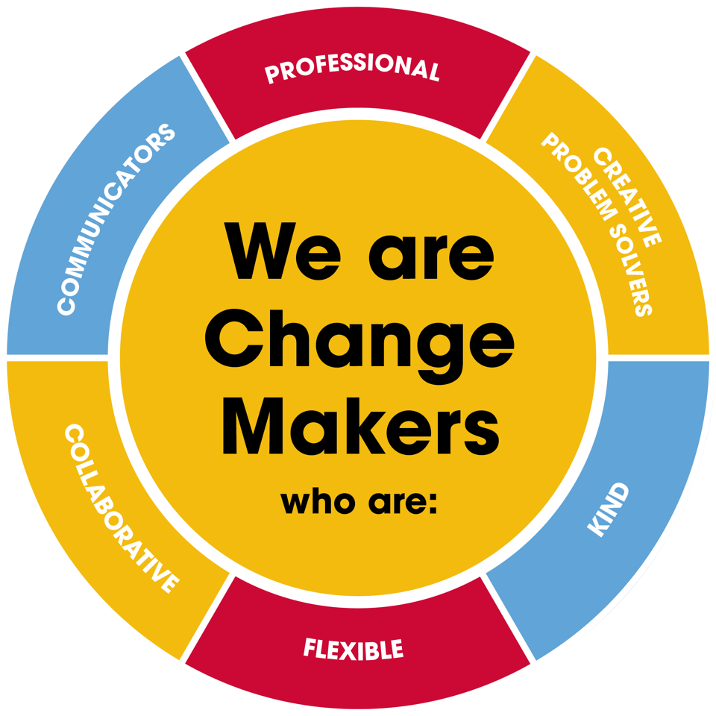
Value scales:
This value is the least important to the role | This value has some significance to the role | This value is desirable to the role but not essential | This value is important to the role | This value is essential to the role
1 | 2 | 3 | 4 | 5

In the role of CBT Therapist (School-Based) we are looking for Change Makers who are (please highlight as appropriate):

Professional: | 1 | 2 | 3 | 4 | 5
Creative Problem Solvers: | 1 | 2 | 3 | 4 | 5
Kind: | 1 | 2 | 3 | 4 | 5
Flexible: | 1 | 2 | 3 | 4 | 5
Collaborative: | 1 | 2 | 3 | 4 | 5
Communicator: | 1 | 2 | 3 | 4 | 5

