**SOUS CHEF**

**STOWE SCHOOL**



Stowe School is a co-ed secondary independent boarding and day school of 895 pupils set in a sublime environment. We have an exciting opportunity for a dynamic and enthusiastic Sous Chef to join our Kitchen and Food Services Team. The ideal candidate would possess a passion for food and cooking with fresh ingredients. We are a busy department providing an array of meal services to the school and external clients such as; our core food offer for pupils and staff, Headmaster’s lunches and dinners, School banquets, Stowe parents’ events, formal society dinners, wedding events, corporate hospitality and lots more. You will require drive and energy and should be happy working in a pressured environment with a dedicated team. If you feel you have the right qualities for this role and would enjoy working in beautiful surroundings then we would be delighted to hear from you.

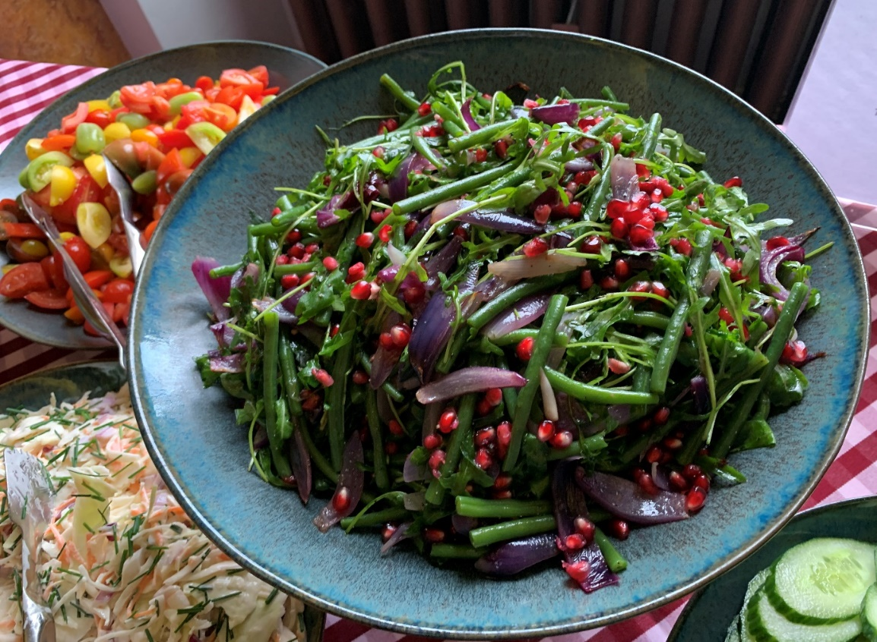

**Sous Chef - Job Description**

**Job Title: Sous Chef**

**Department: Food Services and Hospitality**

**Accountable to: Executive Chef**

**Liaison with: Food Services Manager and other School stakeholders**

**Responsible for: Kitchen team when on shift although reporting line is to the Executive Chef**

**Purpose of the job:**

To assist in all aspects of food preparation and service requirements to achieve the highest standards expected by the School during both term time and non-term time.

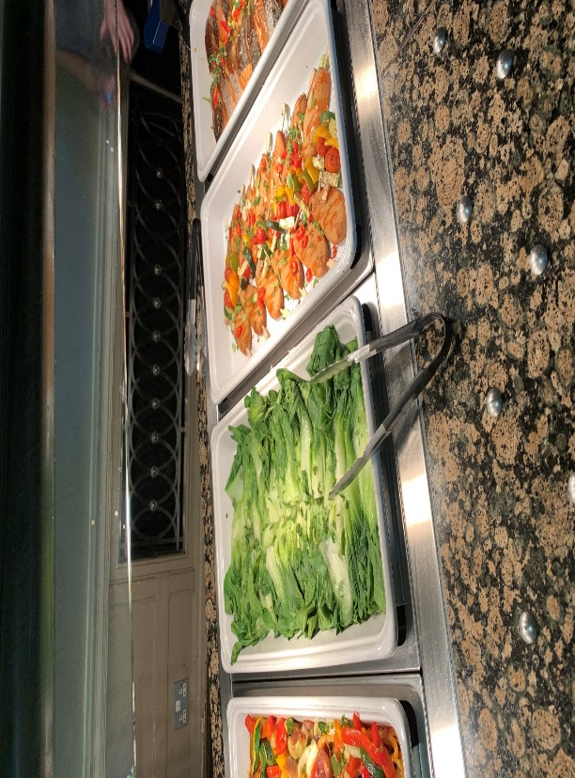

**Context:**

Stowe School occupies Stowe House and about 200 acres of the Stowe estate, and is located in Stowe’s world-famous landscape gardens set in 880 acres. Stowe School is an independent

co-educational boarding School with approximately 870 pupils. There are around 400 full and part-time staff with 80 staff and their families living on site. The National Trust manages the landscape gardens and opens the grounds to over 100,000 visitors a year. Stowe House is open to the public during the School holidays and, for guided tours, during term time.

Stowe School is committed to safeguarding and promoting the welfare of children and expects all staff to share in this commitment.

**Values and Behaviours:**

The post-holder is expected to act professionally at all times and in accordance with the standards of behaviour and code of conduct outlined in the staff handbook and below. In particular we aspire to the following standards of behaviour for the Stowe community:

The Stowe Community is committed to working together to achieve Stowe’s aims and objectives. It is a Christian community that aspires to excellence through working efficiently whilst being responsive to change, adding value where possible and using resources wisely. We collaborate to work both as individuals and as members of a team, communicating and consulting often and openly to the highest standards. We act with integrity and treat each other considerately, valuing diversity and rejecting discrimination. We operate within the appropriate laws and regulations. We are accountable to each other and to our pupils, parents, governors, trustees and visitors. The Stowe Community is both environmentally and socially responsible, recognising the importance of an appropriate work/life balance.

**Key Responsibilities and Accountabilities**:

**Ensuring Exceptional Culinary Food Quality**

* To prepare all food items for breakfast, lunch, dinner and all School events to the highest standard.
* To assist the Exec Chef/Head Chef in all aspects of purchasing, production, storage and service of food and deputising in their absence.
* To maintain the supervision and control of food safety, hygiene and health and safety within the kitchen areas.

**Key Tasks:**

1. To lead and supervise the kitchen team to ensure food production and food presentation meet the highest standards as expected by the School, giving clear guidance and on job training to the team as required.
2. To supervise the kitchen porter team to ensure the highest standards of hygiene and cleanliness are met in full, giving direction as required.
3. To prepare high quality dishes as required by the School including events such as Speech Day, Leaver’s Ball, Society Dinners, Head’s lunches and external events such as weddings, conferences and summers school outside normal term time.
4. To monitor and manage food production in an effective way, limiting wastage and identifying where wastage can be recycled.
5. Overseeing the recording of wastage daily and reporting weekly to the Executive Chef.
6. To follow kitchen production planned numbers as outlined daily by the Exec Chef, batch cooking wherever possible to limit wastage and maintain product quality.
7. Plays a role in determining how food should be presented with the Exec Chef/Head Chef following recipe guidelines and developing recipes as needed.
8. To assist with menu planning and recipe development regularly to bring consistency to the menu cycle and food offer.
9. Takes responsibility for the forward planning and preparation of quality food for the core School food offer alongside other events and special functions.
10. Actively takes part in the daily team briefing outlining school activity and distributing tasks to the team.
11. Obtains the relevant reports for kitchen production and school activity via the electronic department diary communicating requirements to the team.
12. To brief the Food Service team prior to each service outlining dish content, allergens, portion sizes and demonstrating how the food should be presented/plated.
13. Works alongside the Food Service team during service to monitor food levels ensuring food items are continually available and service flows seamlessly.
14. To ensure that all produce is checked on delivery, stored correctly and kept secure.
15. To ensure that all areas are secure at the end of the shift and kitchen left in a clean, tidy and safe condition.
16. To ensure all HACCP paperwork is up to date, is completed correctly at the end of each shift, and any issues highlighted to the Exec Chef.
17. To ensure that all aspects of Food Safety Act are met in full.
18. To carry out the development and training of members of kitchen staff as agreed and outlined by the Exec Chef.
19. To order supplies via the online Pelican system as required.
20. To monitor trends within the market place, utilising new innovations to ensure quality is balanced with value for money.

Hours of Work – An average of 40 hours per week, 52 weeks per year.

**Working a shift pattern with alternate weekends off. An example of the shift patterns are as follows:**

**Example Early Shift:** 6.00am – 2.00pm

**Example Late Shift:** 11.30am – 8.00pm

**Example Split Shift**: 6.00am–2.00pm/4.00pm-8.00pm (limited shift)

A degree of flexibility with working hours will be required at busy times. The rota pattern will be discussed at interview.

This job description reflects the present requirements of the post and as duties and responsibilities change/develop, the job description will be reviewed and be subject to amendment in consultation with the post holder.

February 2022

**Person Specification**

The selection of candidates for short-listing will be based on this specification and candidates should bear this in mind when preparing their application and completing the application form:

|  |  |  |
| --- | --- | --- |
| **Attributes** | **Essential** | **Desirable** |
| **Qualifications** | * Formal catering qualification C&G 706 1 /2 or NVQ 3 |  |
| **Specialist Skills & Experience** | * Four years practical kitchen experience * Volume catering experience * Function catering experience * Supervisory skills/experience * Level 2 food hygiene certificate * Able to work shift patterns/flexibility | * Education catering background * Ordering experience |
| **Personal Qualities** | * Team player with energy and drive * Positive ‘ can do’ attitude * A Leader * Passion for food and service |  |

**REMUNERATION AND OTHER BENEFITS**

This is a full-time post and we offer a competitive salary of £32,000 dependant on skills and experience. 25 days holiday plus public holidays, uniform is provided and laundered, free meal when on duty, use of leisure facilities and grounds, staff pension scheme, discounted membership to golf club. The school is closed at Christmas and New Year.