**Chef de Partie**

**STOWE SCHOOL**



Stowe School is a co-ed secondary independent boarding and day school of set in a sublime environment. We have an exciting opportunity for a dynamic and enthusiastic Chef de Partie to join our Kitchen and Food Services Team.

 The ideal candidate would possess a passion for food and cooking with fresh ingredients. We are a busy department providing an array of meal services to the school and external clients such as; our core food offer for pupils and staff, Head’s lunches and dinners, School banquets, Stowe parents’ events, formal society dinners, wedding events, corporate hospitality and lots more. You will require drive and energy and should be happy working in a pressured environment with a dedicated team.

We know that a work/life balance is important, so our shift pattern’s are based on 40 hours per week. If you feel you have the right qualities for this role and would enjoy working in beautiful surroundings then we would be delighted to hear from you.

**Context**

Stowe School occupies Stowe House and about 200 acres of the Stowe estate, and is located in Stowe’s world-famous landscape gardens set in 880 acres. Stowe School is an independent co-educational boarding School with approximately 870 pupils. There are around 400 full and part-time staff with 80 staff and their families living on site. The National Trust manages the landscape gardens and opens the grounds to over 100,000 visitors a year. Stowe House is open to the public during the School holidays and, for guided tours, during term time.

Stowe School is committed to safeguarding and promoting the welfare of children and expects all staff to share in this commitment.

**WE ARE CHANGE MAKERS**

The Stowe Group have a talented and committed workforce. We are committed to fostering team engagement, attracting, mentoring, developing and retaining our best teachers and non-teaching staff. We focus on employee well-being, provide opportunities for professional growth and create a culture of community and partnership.

**Values and Behaviours**

The post-holder is expected to act professionally at all times and in accordance with the standards of behaviour and code of conduct outlined in the staff handbook and below. In particular we aspire to the following standards of behaviour for the Stowe community:

The Stowe Community is committed to working together to achieve Stowe’s aims and objectives. It is a Christian community that aspires to excellence through working efficiently whilst being responsive to change, adding value where possible and using resources wisely. We collaborate to work both as individuals and as members of a team, communicating and consulting often and openly to the highest standards. We act with integrity and treat each other considerately, valuing diversity and rejecting discrimination. We operate within the appropriate laws and

regulations. We are accountable to each other and to our pupils, parents, governors, trustees and visitors. The Stowe Community is both environmentally and socially responsible, recognising the importance of an appropriate work/life balance.

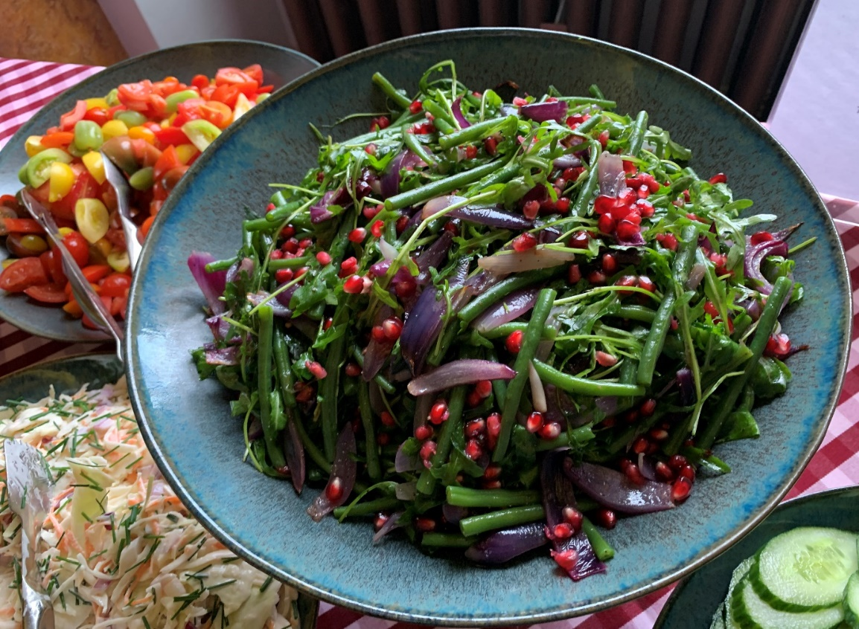

**Chef de Partie - Job Description**

**Job Title: Chef de Partie**

**Department: Food Services and Hospitality**

**Accountable to: Executive Chef**

**Liaison with: Food Services Manager, Kitchen and Food Service Teams, other School Stakeholders, Pupils and Parents**

**Responsible for: No direct reports**

**Purpose of the job**

To assist in all aspects of food preparation and service requirements to achieve the high standards expected by both School and events.

**Key Responsibilities and Accountabilities**:

Ensuring Exceptional Culinary Food Quality and to provide assistance with food production and food service.

To comply with all statutory, legislative and departmental requirements relating to Health, Hygiene and Safety.

**Core Pupil and Staff offer**

**Key Tasks:**

1. To prepare and cook an array of dishes to a high standard as required by the school including out of term events such as conferences, weddings and school banquets.

1. To be present during various service periods monitoring food levels and co-ordinating with the kitchen team.

1. To work collectively with other members of the kitchen team, taking responsibility for food production and ensuring the kitchen meet demand in the absence of the Head Chef or Sous Chefs.

1. To ensure that all aspects of the Food Safety Act are met and report any concerns to the Executive Chef/Head Chef.
2. To liaise with, and work along members of the Food Service Team.
3. To ensure the Food Service Team are aware of food allergens at the various service times.
4. To maintain the required standards of personal hygiene and tidiness within the kitchen areas.
5. To place food orders as required.
6. To ensure, when necessary, that all products are checked on delivery and stored in the appropriate areas.
7. To use the school’s electronic database to gain information regarding school events, and producing food as required for the various events.

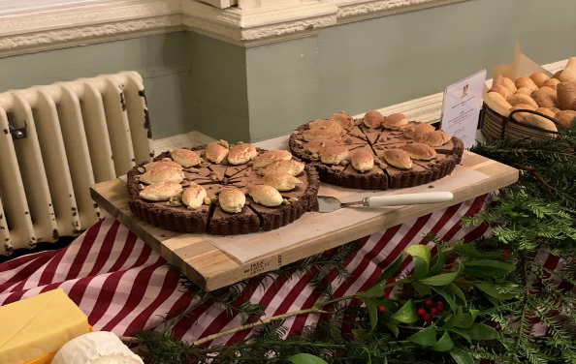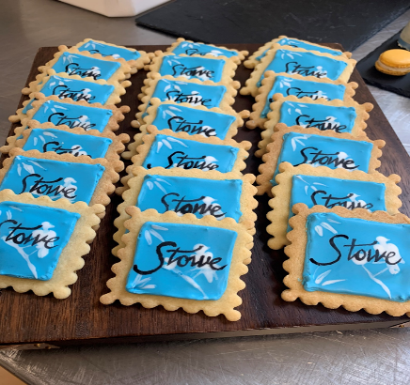

1. To adhere to Health & Safety legislation, reporting incidents to the Head Chef.
2. To maintain departmental standards of tidiness and cleanliness.

**Stowe Buffet**

1. To offer guidance and training to junior members of the kitchen brigade.
2. To work as a team player to ensure all departmental requirements are met in full.

This job description reflects the present requirements of the post and as duties and responsibilities change/develop, the job description will be reviewed and be subject to amendment in consultation with the post holder.

**Person Specification:**

|  |  |  |
| --- | --- | --- |
| **Attributes** | **Essential** | **Desirable** |
| **Qualifications** | · Formal Catering qualification C&G 706 1 /2 or NVQ 1 /2 | · NVQ 3 in Catering |
| **Specialist Skills & Experience** | · Minimum three years practical kitchen experience in food  service    · Able to work shift patterns/flexibility | · Volume catering experience    · Level 2 Food Hygiene  Certificate    · Food Allergan Certificate    · Experience in Schools,  · Colleges/Education Sector |
| **Personal**  **Qualities** | · Team player with energy and enthusiasm    · Positive “can do” attitude    · Flexible approach |  |

**Salary**: £27,500 per annum

**Hours of Work** - An average of 40 hours per week, 52 weeks per year.

**Working a shift pattern with alternate weekends off. An example of the shift patterns are as follows:**

**Early Shift:** 6.00am - 2.00pm

**Late Shift:** 11.30am - 7.30pm

A degree of flexibility with working hours will be required at busy times. The rota pattern will be discussed at interview.

**What we can offer you**

As part of our Stowe Group family, you can access many benefits to include:

· 25 days annual leave plus 8 days bank holiday

· Free Laundered uniform

· Free meals, refreshments and onsite parking

· Pension contribution

· x2 salary Death in Service benefit

· Discounted School Fees – 50% across all Schools in the Stowe Group

· Annual Golf Membership for colleague and immediate family

· Use of School facilities – gym/swimming pool for colleague and family

· Free Flu vaccination

· Free eye test and contribution towards new glasses

· 10% discount in the School Shop

· Great learning and development opportunities

**The Stowe School Group** is committed to safeguarding and promoting the welfare of children and expects all staff to share in this commitment.