**Food Services Assistant – Deliveries**

**A BIT ABOUT US:**

Stowe School occupies Stowe House and approximately 200 acres of the Stowe estate, and is located in Stowe’s world-famous landscape gardens set in 880 acres. Stowe School is an independent co-educational boarding School with approximately 870 pupils. There are around 400 full and part-time staff with 80 staff and their families living on site.

In January 2021, Winchester House and Swanbourne House Schools became part of The Stowe Group. The schools occupy sites of historical significance in Swanbourne, in the market town of Brackley and in the beautiful gardens at Stowe, where we work with The National Trust to manage the landscape gardens and open the grounds to over 200,000 visitors a year. Stowe House is also open to the public during the school holidays.

**WE ARE CHANGE MAKERS**

The Stowe Group have a talented and committed workforce. We are committed to fostering team engagement, attracting, mentoring, developing and retaining our best teachers and non-teaching staff. We focus on employee well-being, provide opportunities for professional growth and create a culture of community and partnership.

**Food Services Assistant – Deliveries**

At Stowe we are looking for a Food Services Assistant - Deliveries to work in our busy, friendly team. This is a key role in managing the logistics of the food services department, delivering equipment and catering requests around various locations on the School grounds. You will be the face of the department who has regular contact with Houseparent’s, Matrons, Pupils, and other School colleagues, so a friendly approach and great communication skills are essential.

You will work closely with the Stores Co-ordinator to ensure correct provisions are delivered into Boarding Houses and all relevant documentation is completed, costs are updated and entered into stock system.

You must have a clean driving license D1 and will have full use of our School transit van.

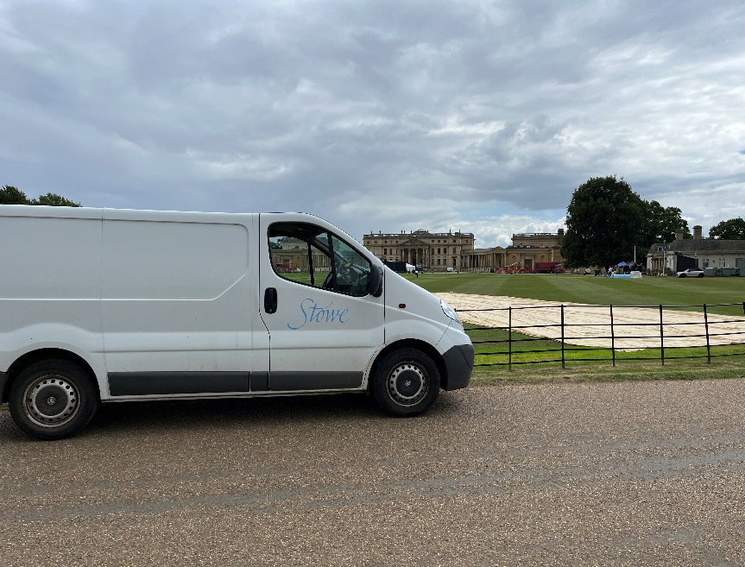

**About you**: This is a great role for someone who enjoys working in a busy and varied environment, managing their workload and delivering a great level of service. You will be comfortable working independently and as part of a team.

If you have previous hospitality experience that’s great but if not don’t worry as you will be fully trained on all aspects of the role. You must be good with people, work well in a busy environment and enjoy being part of a team where flexibility and an ‘all hands on deck’ approach is sometimes required!

**Shift Pattern:**

We recognise the importance of striking a work/life balance and being able to plan ahead so our working pattern is:

* Tuesday to Saturday, 9.00am – 18.00pm with an hour for lunch
* 40 hours per week, 52 weeks per year

**Salary:**

* £22,968 per annum.

**WHAT DOES THE STOWE GROUP OFFER YOU?**

As part of our Stowe Group family, you can access many benefits to include:

* Free uniform
* 25 days plus 8 days bank holiday (pro rata’d dependent on the hours you work)
* Free meals, refreshments and parking
* Competitive pension scheme
* Discounted School Fees – 50% across all Schools
* Annual Golf Membership for colleague and immediate family
* Use of School facilities – gym/swimming pool for colleague and family
* Death in service benefit
* Wellbeing benefits including free Flu vaccination and eye tests
* 10% discount in the School Shop
* Learning and development opportunities

**How to apply:** An application form and job description may be downloaded from our website [Stowe - Job Vacancies](https://www.stowe.co.uk/careers-at-stowe) or you can send a CV. However if you need any help with the application process please contact: [recruitment@stowe.co.uk](mailto:recruitment@stowe.co.uk) 01280 818005

**The Stowe School Group** is committed to safeguarding and promoting the welfare of children and expects all staff to share in this commitment.

**Application deadline:** This post will close on the closing date stated at midnight. If we receive a large number of applications or there is a change in circumstance, we may be required to close a job before to the closing date.

**Contacting you:** We will contact candidates through the email address supplied on their application form. Please make sure you check this regularly.