Food Services and Hospitality Supervisor
STOWE SCHOOL

Stowe School is a co-ed secondary independent boarding and day school set in a sublime environment within the Buckinghamshire countryside. We have an exciting new role for someone with experience in leading a team in food service and hospitality. We require an enthusiastic person to work closely with our front of house team ensuring service is smooth and well run.

We provide a range of services for the School including, Pupil meals, headmaster’s lunches, formal dinners, weddings and summer balls to name but a few. Our business is very varied, so if you enjoy a wide range of activity we may be what you are looking for. We are a busy department, so you’ll need plenty of energy and drive, as well as great people management skills.

The successful applicant will ideally have supervisory experience in a hospitality setting, be well organised and have very good customer service skills. You will be used to setting high standards, enjoy working as part of a team and sharing your ideas and experience.

We recognise it’s important to strike a work/life balance so our rota’s are based on 40 hours per week, 52 weeks per year and we can do these a term in advance so you can plan life! If you feel you have the right experience and skills for this role, we would love to hear from you!

Context

Stowe School occupies Stowe House and about 200 acres of the Stowe estate, and is located in Stowe’s world-famous landscape gardens set in 880 acres. Stowe School is an independent co-educational boarding School with approximately 870 pupils. There are around 400 full and part-time staff with 80 staff and their families living on site. The National Trust manages the landscape gardens and opens the grounds to over 100,000 visitors a year. Stowe House is open to the public during the School holidays and, for guided tours, during term time. Stowe School is committed to safeguarding and promoting the welfare of children and expects all staff to share in this commitment.
We are change makers
The Stowe Group have a talented and committed workforce. We are committed to fostering team engagement, attracting, mentoring, developing and retaining our best teachers and non-teaching staff. We focus on employee well-being, provide opportunities for professional growth and create a culture of community and partnership.
Values and Behaviours
The post-holder is expected to act professionally at all times and in accordance with the standards of behaviour and code of conduct outlined in the staff handbook and below. In particular we aspire to the following standards of behaviour for the Stowe community:

The Stowe Community is committed to working together to achieve Stowe’s aims and objectives. It is a Christian community that aspires to excellence through working efficiently whilst being responsive to change, adding value where possible and using resources wisely. We collaborate to work both as individuals and as members of a team, communicating and consulting often and openly to the highest standards. We act with integrity and treat each other considerately, valuing diversity and rejecting discrimination. We operate within the appropriate laws and
regulations. We are accountable to each other and to our pupils, parents, governors, trustees and visitors. The Stowe Community is both environmentally and socially responsible, recognising the importance of an appropriate work/life balance.

Front of House Supervisor - Job Description

Job Title: Front Services Supervisor (Front of House)

Department: Food Services and Hospitality

Accountable to: Food Services Manager

Liaison with: Food Services Manager, Kitchen and Food Service Teams, other School Stakeholders, Pupils and Parents
Responsible for: No direct reports

Purpose of the job:

To provide and maintain a high standard of food and beverage service to pupils of the School, parents, guests and to delegates outside of term time. Working closely with the Departmental Management Team to ensure the smooth running of the food service areas and the delivery of service quality and cleanliness standards.

To strive to continually improve pupil, guest and staff satisfaction.

To supervise and train staff in the processes and standards of the Food Services and Hospitality Department. Maintain standards and controls under the Food Safety and Health and Safety at Work Act.

Key Responsibilities and Accountabilities:

- To provide support and assistance with the supervision and running of the Food Services Team.
- To ensure the maintenance and delivery of a highly professional service, and personal standards of the Food Services Team whilst on duty.
- To provide support to the Department’s Management Team, taking a leading role in the food and beverage services provided to the School.

- To support all activities of the School that may require a food and hospitality service both during and outside term.

Key Tasks:

- To establish and prioritise the food services workload to ensure that deadlines are met with particular attention to the Front of House and Pantry Areas.
- To ensure that the activities associated with, and within, the food services areas are carried out effectively and to the correct standard.
- To be responsible for leading Service on various shifts, giving clear instruction to the team ensuring that the meal period/event runs smoothly and to support staff with service as needed; the post holder is required to be active in the delivery of the service (hands-on).
- To work with the Management Team to set standards of food/beverage presentation and display, ensuring these standards are adhered to across various services.
- To set an example to other members of the team, in particular casual members of staff, teaching, coaching and encouraging the development and improvement of skills.
- To oversee and, when necessary, prepare the dining rooms, servery areas and other dining /event areas for the appropriate School meal/service, ensuring that the high standards are maintained.
- To take an active role at School events and dinners.
- To be responsible for the department’s immediate Front of House ancillary areas, overseeing the correct levels of tidiness and cleanliness are adhered to and ensuring correct procedures are followed for stock rotation and Food Safety.
- To work with other Food Service Supervisors to ensure all menus and point of sale are correct and that allergens are correctly identified to the customer.
- To play an active role within the team, contributing to a positive atmosphere across the department and within the wider School community.
- To use the electronic diary system to record and acquire information regarding the School’s catering commitments.
- To respond to emails from the School regarding catering requirements in a timely and appropriate manner as and when required.
- To take a key role in team briefs prior to service and on occasion at team meetings.
- To assist with the delivery and set up of food and beverage items at other locations in the School grounds, using the department’s allocated transport as required.
- To liaise with the Executive Chef regarding the purchasing of stock items for the Front of House areas.
- To assist the Deputy Food Services Manager to maintain appropriate Health and Safety within their scope of responsibility.

- To report any defects/breakdowns in service equipment immediately to the Maintenance Department and to monitor timelines for active repair.
- To ensure the correct handling and storage of cleaning materials and equipment. Monitoring store levels to ensure sufficient stock and ordering as required.
- To undertake any other appropriate tasks as requested by the Head of Department/ Management Team or Senior School Officer.

This job description reflects the present requirements of the post and as duties and responsibilities change/develop, the job description will be reviewed and be subject to amendment in consultation with the post holder.

Person Specification

The selection of candidates for short-listing will be based on this specification and candidates should bear this in mind when preparing their application and completing the application form:

Attributes | Essential | Desirable
Qualifications | - Basic Food Hygiene Certificate  - A driving licence | - Health & Safety Certificate  - Supervisory Certificate  - COSHH Certificate  - Food Allergen Certificate
Specialist Skills & Experience | - Supervisory experience  - Customer focussed background in a service industry  - Working as part of a small team  - Food Service experience | ● Hospitality/table service experience
Personal Qualities | - Has an eye for detail  - Works to high standards  - Good organisational and communication skills  - Strong leadership qualities  - Adaptable, flexible, positive outlook  ● IT literate  - Ability to work unsupervised and on own initiative  - Able to physically carry out the tasks associated with a high volume food service environment.

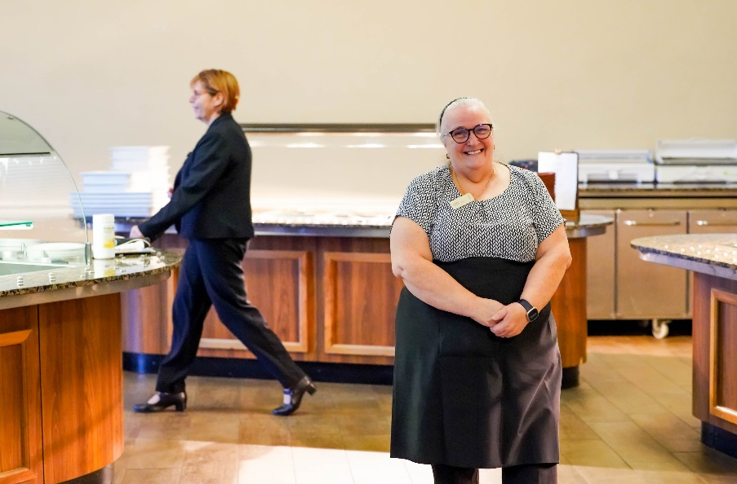
Salary: £25,500 per annum

Hours of Work - An average of 40 hours per week, 52 weeks per year.

Working a shift pattern with alternate weekends off. An example of the shift patterns are as follows:
Early Shift: 6.45am - 2.30pm Late Shift: 12.00 noon – 8.15pm *

*Every three weeks there is a break of Exeat weekend or Half Term and rotas can be planned for each term in advance to allow you to plan that important family time.

A degree of flexibility with working hours will be required at busy times. The rota pattern will be discussed at interview.

What we can offer you
As part of our Stowe Group family, you can access many benefits to include:

· 25 days annual leave plus 8 days bank holiday
· Free laundered uniform
· Free meals, refreshments and onsite parking
· Pension contribution
· x2 salary Death in Service benefit
· Discounted School Fees – 50% across all Schools in the Stowe Group
· Annual Golf Membership for colleague and immediate family
· Use of School facilities – gym/swimming pool for colleague and family
· Free Flu vaccination
· Free eye test and contribution towards new glasses
· 10% discount in the School Shop
· Great learning and development opportunities

The Stowe School Group is committed to safeguarding and promoting the welfare of children and expects all staff to share in this commitment.

